8 PUZZLE PROBLEM

AIM:
The aim of the 8-puzzle problem is to arrange the tiles in the correct order by moving one tile at a time into the blank space with the minimum number of moves.

OBJECTIVES:
- To arrange the tiles in the correct order.
- To reach the goal state from the initial state.
- To find the solution using an AI search algorithm.
- To minimize the number of moves required.
- To demonstrate problem-solving using state-space search.

ALGORITHM:
Start.
Read the initial state of the puzzle.
Compare the current state with the goal state.
If the goal state is reached, display "Goal Achieved" and stop.
Otherwise, move the blank space (up, down, left, or right) to generate a new state.
Repeat Steps 3–5 until the goal state is reached.
Display the sequence of moves.
Stop.

FLOWCHART:
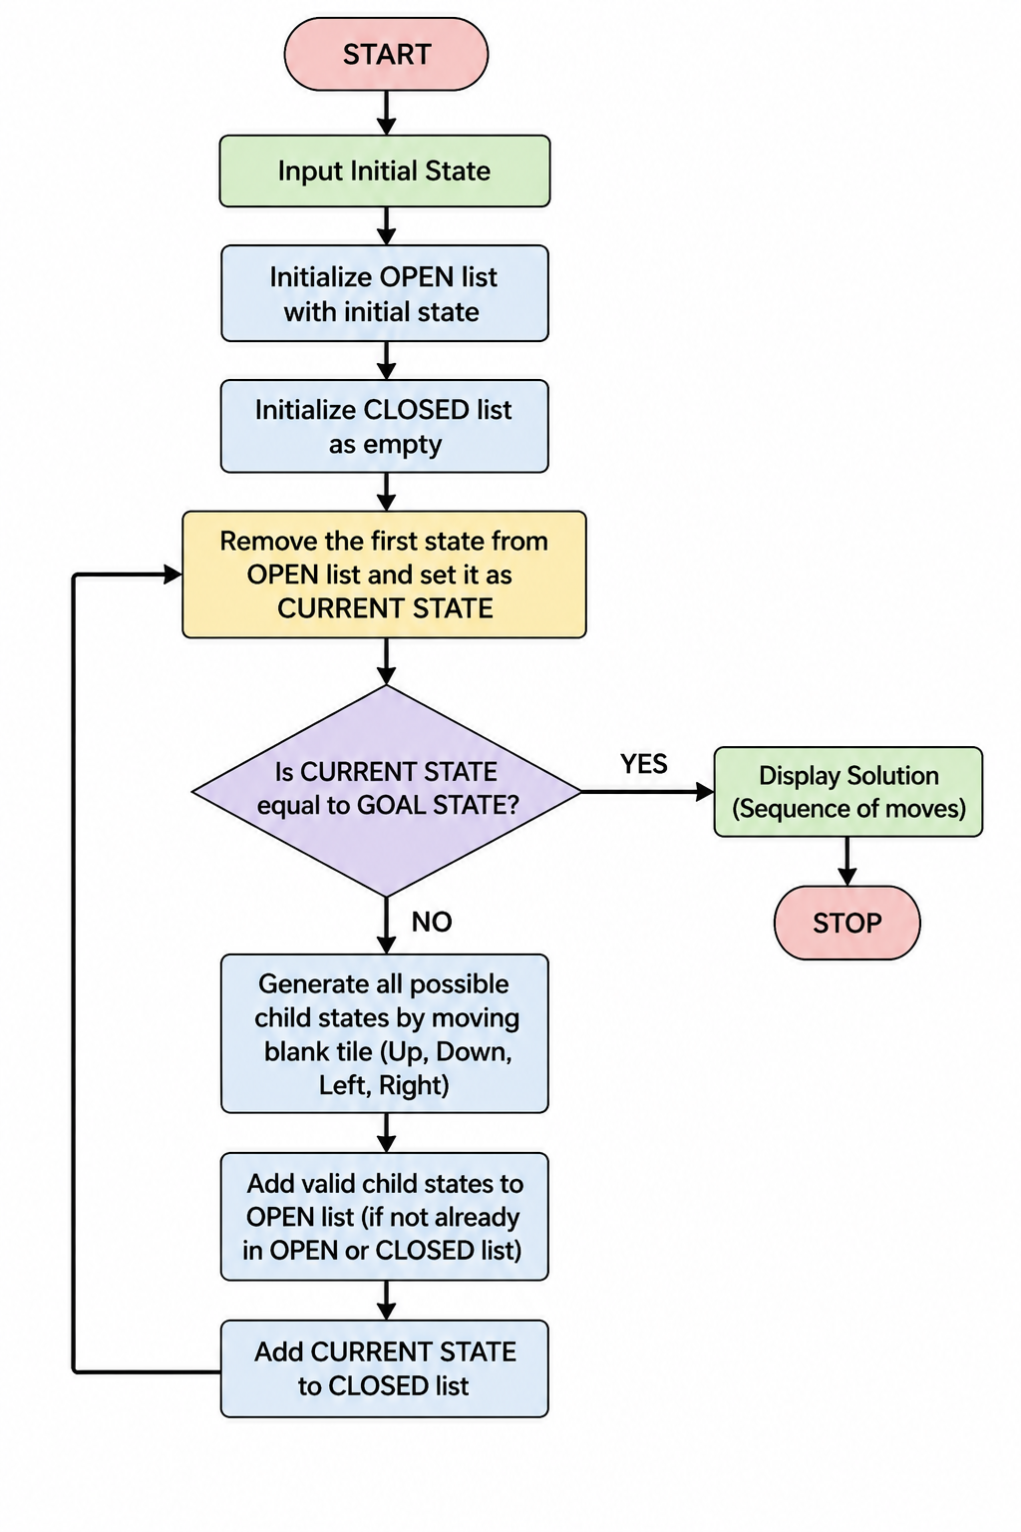

SOURCE CODE:

from collections import deque

start = (1, 2, 3,
4, 0, 6,
7, 5, 8)

goal = (1, 2, 3,
4, 5, 6,
7, 8, 0)

queue = deque([start])
visited = []

while queue:
state = queue.popleft()

if state == goal:
print("Goal State Reached!")
break

if state not in visited:
visited.append(state)

blank = state.index(0)

moves = []
if blank > 2:
moves.append(blank - 3) # Up
if blank < 6:
moves.append(blank + 3) # Down
if blank % 3 != 0:
moves.append(blank - 1) # Left
if blank % 3 != 2:
moves.append(blank + 1) # Right

for move in moves:
new = list(state)
new[blank], new[move] = new[move], new[blank]
queue.append(tuple(new))

OUTPUT:
